**MIS 6308: System Analysis and Project Management**

**Assignment 2**

1. The UML diagrams for DoorDash are as follows:
   1. Context Diagram

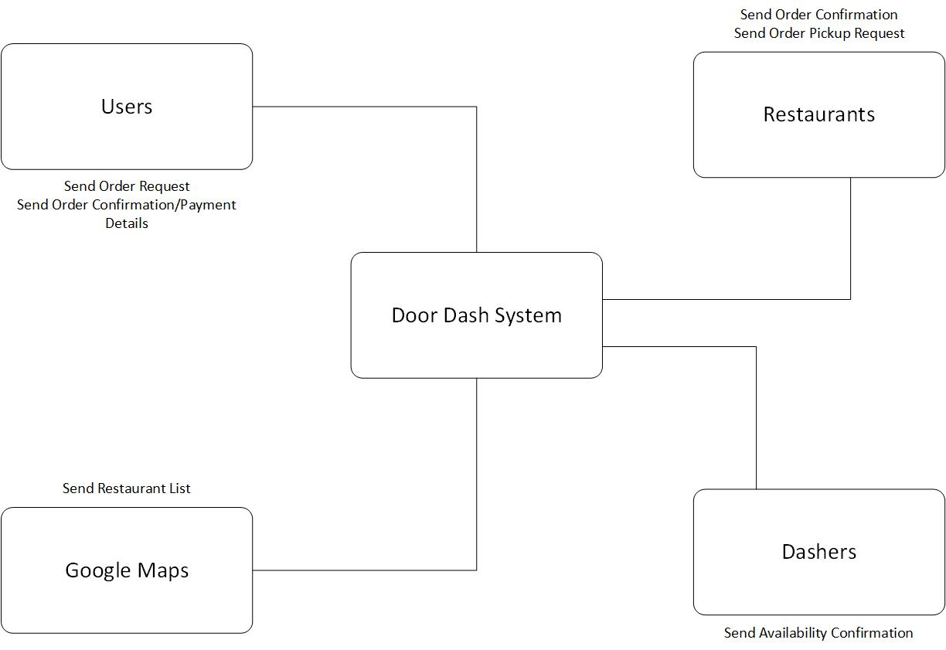

* 1. Use Case Diagram
     1. Level 1

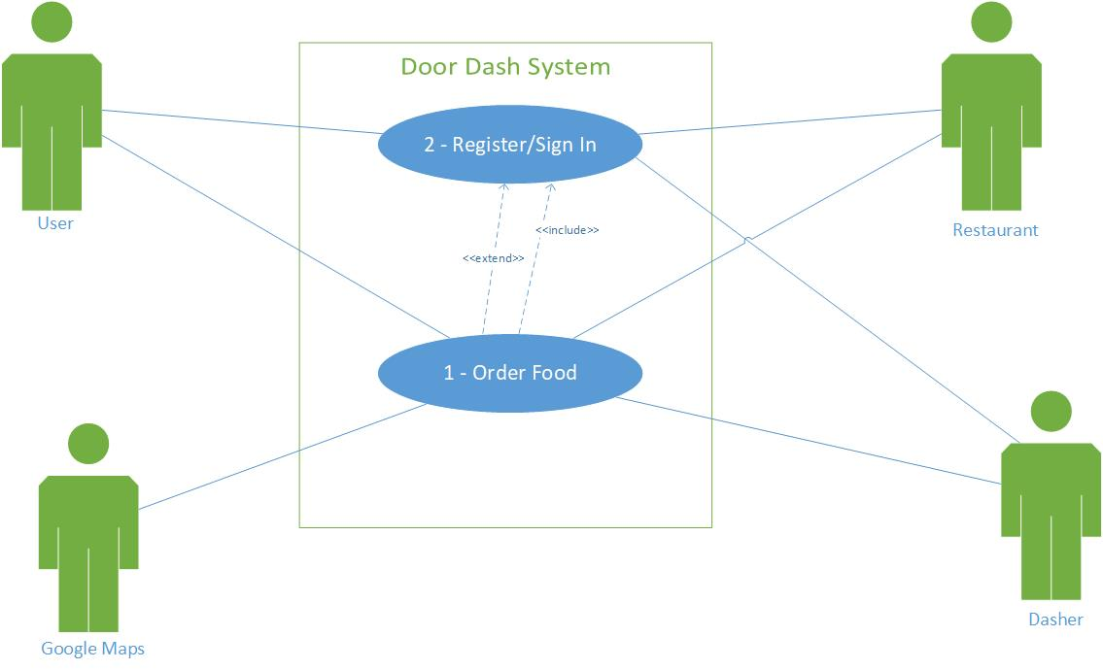

* + 1. Level 2
       1. Order Food

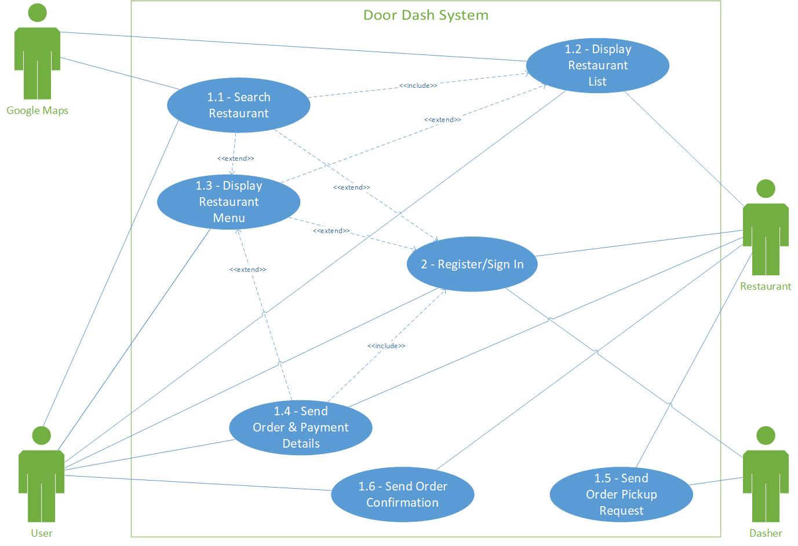

* + - 1. Register/Sign In

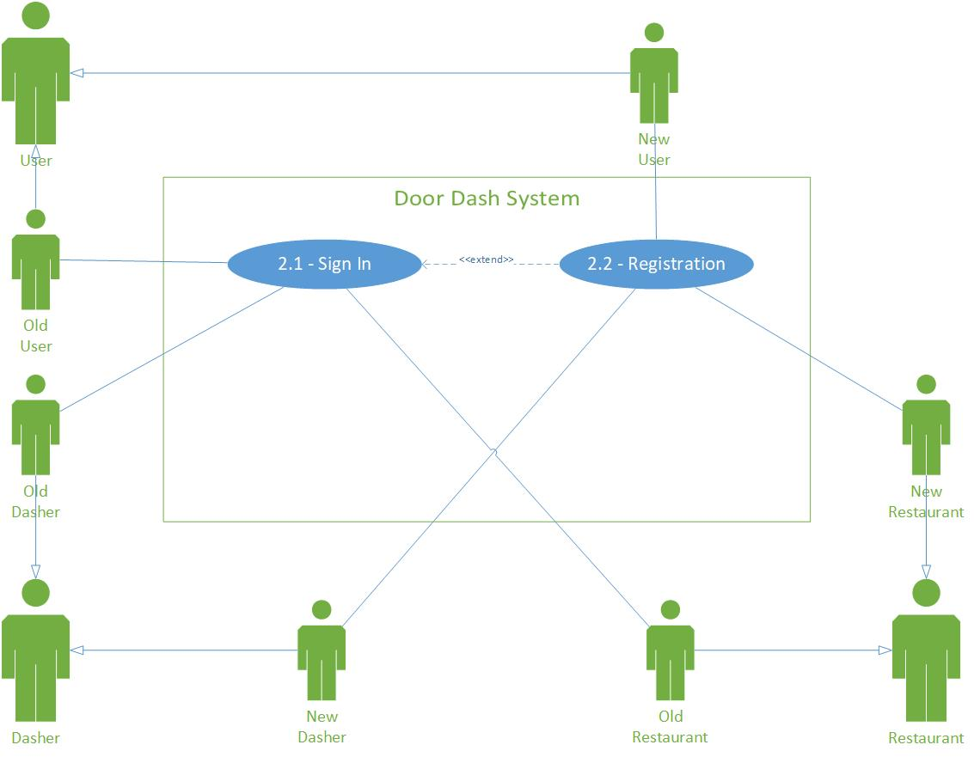

* 1. The description of respective use case diagrams are as follows:

|  |  |
| --- | --- |
| **Use Case Name** | Order Food |
| **Use Case ID** | 1 |
| **Primary Actors** | User, Google Maps, Restaurant, Dasher |
| **Stakeholders & Interests** | User – wants to order food  Restaurant – wants to prepare food to its customers and give it to delivery person on time  Dasher – wants to deliver food from restaurant to customer on time |
| **Brief Description** | This use case describes the process of order of food on DoorDash site |
| **Trigger** | User comes to DoorDash site for ordering food |
| **Trigger Type** | External Trigger |
| **Relationships** | |
| **Association** | User, Google Maps, Restaurant, Dasher |
| **Include** | Registration/Sign In |
| **Extend** |  |
| **Generalization** |  |
| **Normal Flow of Events** | |
| 1. The user comes to DoorDash, searches for restaurant within his/her area. 2. Google Maps receives entered area data and executes *“Search Restaurant”* use case. 3. The user finalizes order details, enters payment details and executes the *“Send Order & Payment”* use case. 4. The restaurant receives order and payment details, prepares food for the order and executes *“Send Order Pickup Request”* use case. 5. The dasher receives the order pickup request,    1. Accepts it, confirmation is sent to restaurant.    2. Declines it, order pickup request is sent to another dasher and step 5 is repeated till pickup is accepted by a dasher. 6. The restaurant receives confirmed order pickup response from dasher and executes *“Send Order Confirmation”* use case. | |
| **Sub Flows** | |
|  | |
| **Alternate/Exception Flows** | |
| 1a – Selects restaurant from the displayed options of restaurants based on previously entered area data and executes the *“Display Restaurant Menu*” use case.  1b – Goes to register/sign in and executes the *“Register/Sign In”* use case. | |

|  |  |
| --- | --- |
| **Use Case Name** | Register/Sign In |
| **Use Case ID** | 2 |
| **Primary Actors** | User, Restaurant, Dasher |
| **Stakeholders & Interests** | User – wants to order food  Restaurant – wants to prepare food to its customers and give it to delivery person on time  Dasher – wants to deliver food from restaurant to customer on time |
| **Brief Description** | This use case describes the process of registration of new actors and sign in for old actors on DoorDash site |
| **Trigger** | Actor comes to DoorDash site |
| **Trigger Type** | External Trigger |
| **Relationships** | |
| **Association** | User, Restaurant, Dasher |
| **Include** |  |
| **Extend** | Registration/Sign In |
| **Generalization** | User – New and old user  Dasher – New and old dasher  Restaurant – New and old restaurant |
| **Normal Flow of Events** | |
| 1. Actor comes to DoorDash, clicks on Register/Sign In button, enters user data    1. If actor is new, executes *“Registration”* use case.    2. If actor is old, executes *“Sign In”* use case. | |
| **Sub Flows** | |
|  | |
| **Alternate/Exception Flows** | |
|  | |

1. Data mentioned in above use case descriptions as per data dictionary notation:

***“Order Food”*** use case:

1. Aggregate Data:
   1. Delivery Area = [Street Address | Zip code]
   2. Street Address = Address Line 1 + (City Name) + (State Name) + (Country Name) + (Zip Code)
   3. Restaurant Options = 0{Cuisine Type + 0{Restaurant Details}}
   4. Restaurant Details = Restaurant Name + Restaurant Description + Restaurant Logo + Street Address + Restaurant Website URL +

1{Restaurant Phone Number} + Restaurant Number of Employees + Restaurant Rating + Restaurant Delivery Hours + Restaurant $ Rating

* 1. Order Details = Order ID + 1{Item} + Payment Details
  2. Item = {Name + Quantity + (Customizations) + (Additional Instructions) + Issue Instruction}
  3. Payment Details = Payment ID + Card Details + (Promo Code) + Total Amount
  4. Card Details = Card Owner Name + Card Number + Expiry Information + CVV Code + Card Zip Code + (Pin Code)
  5. Total Amount = Sub-total + Taxes + Delivery Fee + Service Fee + (Small Order Fee)
  6. Pickup Request = Request ID + Order Details + User Address + Restaurant Address + Delivery Time
  7. Pickup Response = Response + (Reason for response)

1. Data Elements:
   1. Item Name
   2. Item Quantity
   3. Customization
   4. Additional Instructions
   5. Delivery Time
   6. Promo Code
   7. Card Owner Name
   8. Card Number
   9. Expiry Information
   10. CVV Code
   11. Card Zip Code
   12. Sub-total
   13. Taxes
   14. Delivery Fee
   15. Service Fee
   16. Small Order Fee
   17. Response
   18. Reason for response
   19. Zip code
   20. Address Line 1
   21. City Name
   22. State Name
   23. Country Name
   24. Cuisine Type
   25. Restaurant Name
   26. Restaurant Description
   27. Restaurant Logo
   28. Restaurant Website URL
   29. Restaurant Phone Number
   30. Restaurant Number of Employees
   31. Restaurant Rating
   32. Restaurant Delivery Hours
   33. Restaurant $ Rating
   34. Order ID
   35. Request ID
   36. Payment ID

***“Registration/Sign In”*** use case:

1. Aggregate Data:
   1. User Details = First Name + Last Name + Email + Phone Number + Country + Password + (Loyalty Program Information)
   2. Loyalty Program Information = Partner Loyalty Program Name + Loyalty Code
2. Data Elements:
   1. First Name
   2. Last Name
   3. Email
   4. Phone Number
   5. Country
   6. Password
   7. Partner Loyalty Program Name
   8. Loyalty Code
3. Class Diagram

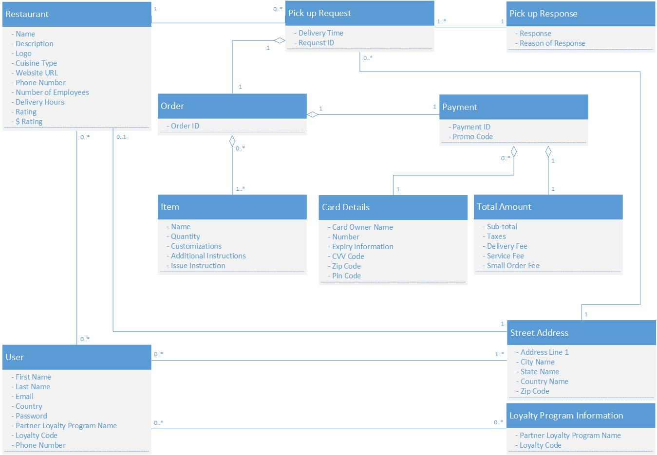

1. Sequence Diagram for ***“Order Food”*** use case

